REQUEST TO SUPPORT THE PA SCHOOL COUNSELING SERVICES ACT
(HOUSE BILL 1825)
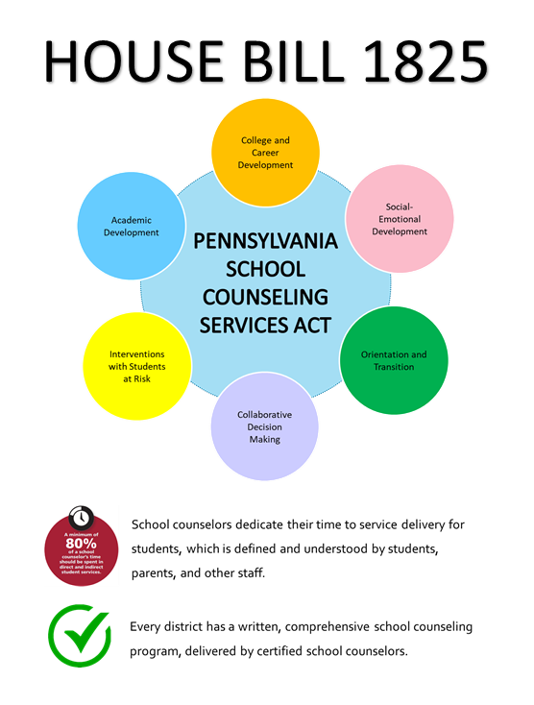
Dear Representative/Senator ___________________________,
My name is (INSERT NAME HERE) and I am a school counselor at (INSERT BUILDING HERE) in the (INSERT DISTRICT NAME HERE) school district. I am writing to ask for your support on House Bill 1825, the Pennsylvania School Counseling Services Act, which was introduced in the House last fall.
Pennsylvania is the only state in America that does not require school districts to outline comprehensive school counseling programs, or require school counselor staffing in schools. They must not only provide services to students and families in real time, but must simultaneously educate and advocate in their schools and communities about their roles and areas of expertise.
This means that not all school counselors are able to work effectively and efficiently with their students, and the types of services provided can look vastly different from one school district to another all across Pennsylvania.
- Since 2010, there are 134 less school counselors working in Pennsylvania public school districts.
- Less than 20% of Pennsylvania public school buildings meet the national benchmark for school counselor to student ratios.
- There are over 80,000 students in over 200 school buildings in Pennsylvania without a school counselor – most of them elementary school students in low income communities.
- Almost half of all Pennsylvania school districts have school counselors splitting their work assignment between multiple buildings resulting in limited availability and services for students and families.
While school counselors have provided responsive services for students in crisis for many years, the need for proactive, preventative, and educational programming specific to mental health and social-emotional learning has been magnified by the disruptions brought to our schools by COVID-19.
The School Counseling Services Act will provide clarity for students and families as to the services they can expect to receive from their school counselors, to school districts who are seeking to support their students effectively through a global pandemic, and to taxpayers who can see their money fund efficient student support services that align with best practices, no matter their zip code or socioeconomic status.
Thank you for supporting our students, their families, and our communities by supporting House Bill 1825!
Sincerely,
(INSERT NAME and INFO HERE)

